**University of Petroleum and Energy Studies** School of Computer Science

Department of Cybernetics



**Graphics & Animation Tools**

**LAB FILE**

**(Session: 2020-2021)**

Course: B. Tech with Specialization in Open Source and Open Standards 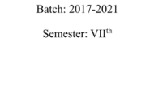

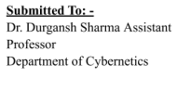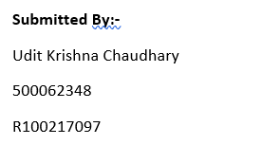

**Experiment - 7** Design of 3D Rocket using Blender.

We need to create a 3D Rocket in this experiment.

1. Open Blender, and clear everything from the interface which is already there.

2. Select mesh and then select a cone, switch vertices to 12.

3. Scale down the cone to 0.5, drag it towards the z-axis, and then enter tab. Now in the edit mode, select the face-select mode.

4. Now after selecting the bottom-face extend it along the z axis. And scale it accordingly.

5. Now add a cylinder at the bottom of the cone and add it again to make it longer.

6. Now using the knife tool cut the edges of the bottom cylinder and extend it towards the bottom, creating a triangle like shape.

7. Now do it for the other edges.

8. Now in the middle cylinder just push the edges of the cylinder inwards to give it a shape of a rocket.

9. Now export your project from blender, and render some more images. **Output**

